SARASWATI BAL MANDIR, PASCHIM VIHAR
ASSIGNMENT
CLASS: X
SUBJECT: MATHEMATICS
- Prove that √3 , √2 , √5is irrational.
- Show that 6–7√3 is irrational.
- Find the HCF and LCM of 510 and 92 by the prime factorisation method.
- Find the zeroes of the quadratic polynomial $6x^{2}-3-7x$, and verify the relationship between the zeroes and the coefficients.
- Find a quadratic polynomial, the sum and product of whose zeroes are – √3 and 1/5, respectively.
- Draw the graphs of the equations x – y + 1 = 0 and 3x + 2 y – 12 = 0. Show that the pair of linear equations represent interecting lines. Determine the coordinates of the vertices of the triangle form by these lines and the x-axis and shade the triangular region.
- Five years hence, the age of Jacob will be three times that of his son. Five years ago Jacob’s age was 7 times that of his son. What are their present ages?
- Find the discriminant of the quadratic equation 2$x^{2}$– 4x + 3 = 0, and hence find the nature of its roots.
- Find the values of k for the quadratic equation$2x^{2}+kx+3=0$ so that they have two equal roots
- A train travels a distance of 480 km at a uniform speed. If the speed had been 8 km/h less, then it would have taken 3 hours more to cover the same distance . Find the speed of the train.
- Find the 20th term from the last term of the AP : 3, 8, 13, . . ., 253.
- The first term of an AP is 5, the last term is 45 and the sum is 400. Find the number of terms and the common difference.
- If the sum of first 7 terms of an AP is 49 and that of 17 terms is 289, find the sum of first n terms.
- How many two-digit numbers are divisible by 7?
- State and prove Basic Proportionality Theorem(BPT) and use BPT ,if ABCD is a trapezium in which AB || DC and its diagonals intersect each other at the point O. Show that AO/BO=CO/DO.
- Find the ratio in which the line segment joining A(1, – 5) and B(– 4, 5) is divided by the x-axis. Also find the coordinates of the point of division
- Find the point on the x-axis which is equidistant from (2 ,– 5) and (-2,9).
- Prove $\frac{tanA}{1-cotA}+\frac{cotA}{1-tanA}$= 1+ secA cosecA
- A 1.2 m tall girl spots a balloon moving with the wind in a horizontal line at a height of 88.2 m from the ground. The angle of elevation of the balloon from the eyes of the girl at any instant is 60°. After some time, the angle of elevation reduces to 30°. Find the distance travelled by the balloon during the interval.
- From the top of a 7 m high building, the angle of elevation of the top of a cable tower is 60° and the angle of depression of its foot is 45°. Determine the height of the tower.
- The length of a tangent from a point A at distance 5 cm from the centre of the circle is 4 cm. Find the radius of the circle.
- Prove that the parallelogram circumscribing a circle is a rhombus.
- A chord of a circle of radius 10 cm subtends a right angle at the centre. Find the area of the corresponding: (i) minor segment (ii) major sector. (Use π = 3.14)
- A chord of a circle of radius 15 cm subtends an angle of 60° at the centre. find the area of major sector ,minor sector ,the corresponding minor and major segments of the circle.
- Wooden article was made by scooping out a hemisphere from each end of the solid cylinder. If the height of the cylinder is 10 cm and its base is of radius 3.5 cm, find the total surface area of the article.
- A Solid consisting of a right circular cone of height 120 cm and radius 60 cm standing on a hemisphere of radius 60 cm is placed upright in a right circular cylinder full of water such that its touches the bottom. Find the volume of water left in the cylinder, if the radius of the cylinder is 60 cm and its height is 180 cm.
- One card is drawn from a well-shuffled deck of 52 cards. Find the probability of getting
- a king of red colour
- (ii) a face card
(iii) a red face card
(iv) the jack of hearts
(v) a spade
(vi) the queen of diamonds
- A lot consists of 144 ball pens of which 20 are defective and others are good. Nuri will buy a pen if it is good, but will not buy if it is defective. The shopkeeper draws one pen at random and gives it to her. What is the probability (i)she will buy ? (ii) she will not buy it?
- The median of the following data is 525. Find x and y if the sum of all frequencies is 100.
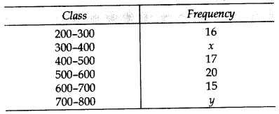
- Find the mode of the following frequency distribution

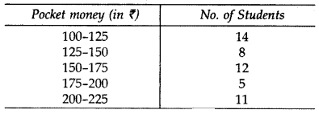
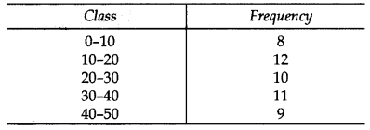
- Monthly pocket money of students of a class is given in the following frequency distribution:
Find mean pocket money .
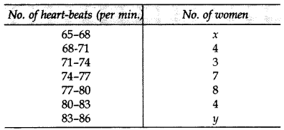
- In the table below, heart-beats of 30 women are recorded. If mean of the data is 76, find the missing frequencies x and y.

